Certificate of Practical Training
ISS



TANZANIA TELECOMMUNICATIONS CORPORATION
This is to certify that
WAHDA ISSA WINDA
a student from
UNIVERSITY OF DODOMA
was attached at the Tanzania Telecommunications Corporation Information Solutions and Services Department, between the dates stated below, for the purpose of Practical Training.
Attachment Period | 21st JULY 2024 | - | 12th SEPTEMBER 2025

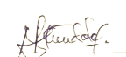 |  |  |  | 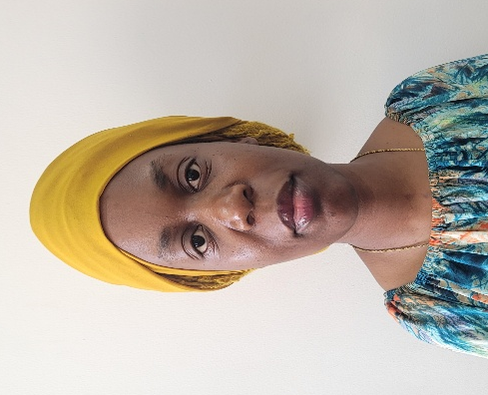
MDEKA MGONELA |  | KAMBEY KISAMBU
IT support supervisor  Information Solutions & Services |  | Manager Information Solutions & Services

